

VPA 12 Terminal Software Update Instructions

Terminal software S301-12 25-July-2014

Controller software 2.213

## The handheld terminal holds new software for both the terminal and the controller. To update:

* Relieve any pressure in the system
* Turn the VPA off using the switch on the back of the controller.
* Disconnect the serial cable from the back of the of the old terminal
* Connect the new terminal, and power the VPA on.
* When prompted to install new software by the terminal, press OK.
* The next screen will ask what range pressure transducer and gear reducer ratio are attached to the VPA. Use the drop down list to select the correct transducer and gear reducer ratio.
  + The gear reducer ratio should be printed on the gear reducer located just below the ball screw.
  + The transducer range will either be printed on the side of the transducer, or if a delta pressure transducer refer to the product documentation for the correct setting.
* Press OK after both values have been entered.
* The download process takes about 30 seconds, when prompted use the switch on the back of the controller to power the pump off, then back on.

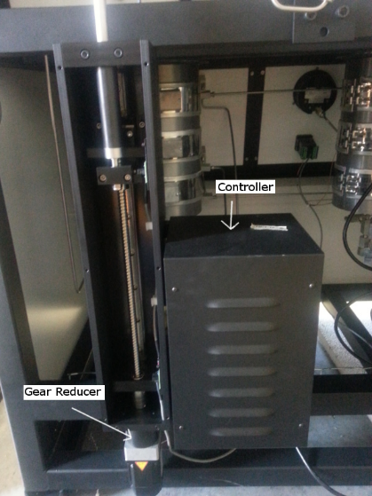

Controller and Gear Reducer

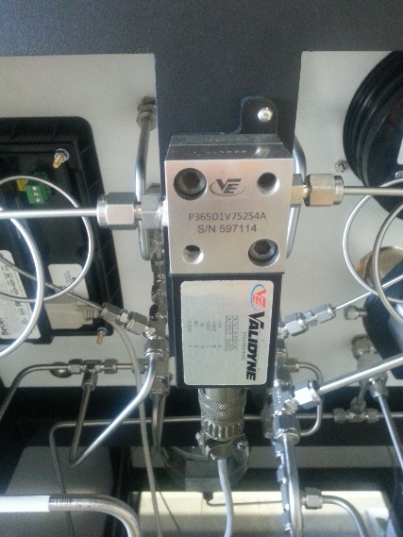

Delta Pressure Transducer

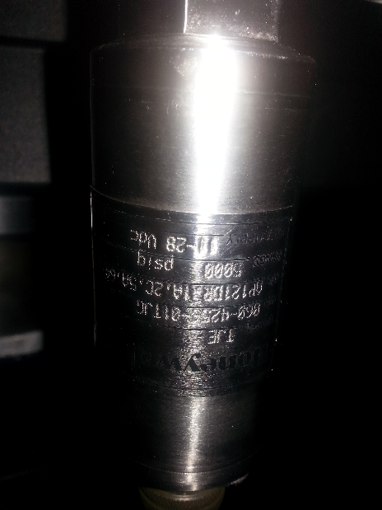

Regular Transducer